EXECUTIVE DATA ANALYTICS INSIGHTS REPORT
TO: Smart-City Mobility Management & Infrastructure Team
FROM: Lead Traffic Data Systems Engineer
DATE: 31 October 2026
SUBJECT: Diagnostic Performance Report — Westbound I-94 Transit Asset Capacity & Environmental Analytics

1. EXECUTIVE SUMMARY
This report provides a data-driven performance assessment of westbound Interstate 94 (I-94), drawing directly from structural SQL telemetry audits, Power BI exploratory dashboards, and programmatic data pipelines. By assessing 48,204 hours of verified sensor logs spanning a multi-year timeline, this analysis isolates historical baseline metrics, diurnal commuter bottlenecks, and macro environmental constraints. The primary goal is to provide the smart-city mobility team with actionable, empirical insights to optimize corridor signal coordination, manage weather-induced capacity constraints, and proactively schedule fleet operations.

2. METHODOLOGY & DATA ASSURANCE PIPELINE
The initial data ingest revealed a row count of 48,205 entries. Structural profiling exposed that the first row contained raw column headers rather than data. A schema repair pipeline programmatically renamed generic field handles (field1 through field9) to explicit domain features (holiday, temp, rain_1h, etc.) and dropped the non-numeric header row, leaving 48,204 valid observations with 9 core columns.
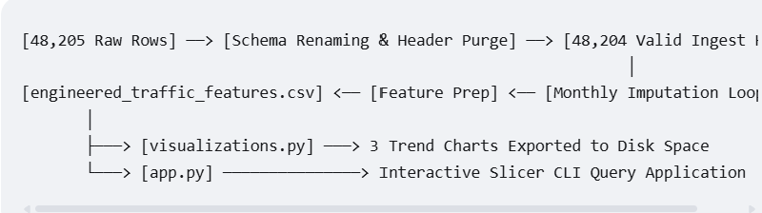
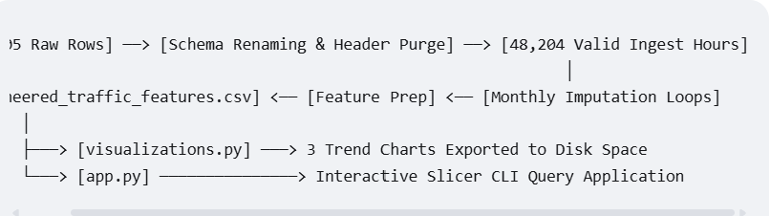
[48,205 Raw Rows] ──> [Schema Renaming & Header Purge] ──> [48,204 Valid Ingest Hours]
│
[engineered_traffic_features.csv] <── [Feature Prep] <── [Monthly Imputation Loops]
│
├───> [visualizations.py] ───> 3 Trend Charts Exported to Disk Space
└───> [app.py] ───────────────> Interactive Slicer CLI Query Application
Critical Telemetry Anomaly Interceptions
- Temporal Tracking Gaps: A macro-level timeline query revealed major data logging dropouts. The year 2012 contains only late-quarter data (October to December). Crucially, the 2014 tracking timeline terminates abruptly in August, and the 2015 tracking does not resume until June. This structural missingness artificially suppresses raw yearly traffic totals for 2014 (15.7M) and 2015 (14.1M) compared to full-year baselines like 2013 (28.1M) and 2017 (35.4M).
- Sensor Failure Dropouts: Scatter plot profiles uncovered a distinct column of anomalies sitting at exactly -273.15°C (0 Kelvin). These do not reflect real-world arctic weather events; they are hardware dropouts where a failed sensor logged a zero instead of a blank field. The pipeline isolates these via a location mask (df['temp'] <= 0) and repairs them using localized monthly running medians to safeguard data integrity.

3. CORE STATISTICAL FINDINGS & ANALYTICAL INSIGHTS
Finding A: Bimodal Commuter Flow vs. High System Volatility
Descriptive statistics for traffic volume reveal an empirical Mean of 3,259.82 vehicles/hour and a Median of 3,380.0 vehicles/hour. While the proximity of these values might suggest a normal distribution, the system is governed by a bimodal daily profile:
- Peak Congestion Mode: Driven by rigid work and school schedules, intense traffic blocks peak between 07:00–08:00 and 16:00–17:00, with average traffic volumes surging past 5,500 to 5,800+ vehicles/hour.
- Off-Peak Mode: Late-night and early-morning traffic drops below 1,000 vehicles/hour.
- Volatility: The Standard Deviation is exceptionally large at 1,986.84 (representing 61% of the mean), proving that traffic rarely hovers around the average. The highway swings between near-emptiness and an empirical saturation ceiling of 7,280 vehicles/hour.
Finding B: Macro Weather Carrying Capacities and Disruption Risks
Freeway capacity shows high resilience across standard weather conditions but remains highly sensitive to localized, severe weather hazards:
- Standard Weather Performance: The highest mean traffic volumes occur during cloudy (Clouds: 3,618.45 vehicles/hour) and clear (Clear: 3,055.91 vehicles/hour) conditions. Commuters maintain normal travel rates during light rain or drizzle.
- Extreme Hazard Reductions: Severe convective wind or extreme winter storm states (Squall) drop the mean hourly traffic volume to 2,061.75 vehicles/hour. This marks an absolute capacity loss of 1,556.70 vehicles/hour (a 43% contraction), caused by reduced safe traveling speeds and drivers actively canceling discretionary trips.
Finding C: Non-Linear Temperature Relationships & Seasonal Nuances
The Pearson Correlation Coefficient between temperature and traffic volume is 0.1323, indicating a very weak positive association. While warmer temperatures show a minor mathematical link to higher traffic, temperature alone is not a primary driver of volume.
- Commuter Resilience: Zoomed scatter plots show the 6,000+ peak vehicle ceiling spans across temperatures from -15°C to +30°C.
- Holiday Temperature Shifts: Granular winter holiday queries reveal that a temperature shift from a deep sub-zero average of -6.12°C (New Year's Day 2016) to a milder winter freeze of -3.06°C (New Year's Day 2017) correlated with a 17.25% traffic surge (climbing from 1,815 to 2,128 vehicles). In contrast, warm-weather holidays like Labour Day hover within a stable baseline window (20.02°C to 22.39°C), meaning temperature variations have minimal impact on holiday travel choices.

4. STRATEGIC RECOMMENDATIONS FOR MOBILITY INFRASTRUCTURE
- Implement Adaptive Signaling Patterns: Program ramp meters and variable speed limit displays upstream to automatically activate at 06:30 and 15:30. Preempting the bimodal morning and evening commuter spikes before volumes cross the 4,500 medium-to-high congestion threshold stabilizes highway merging behavior and delays gridlock onset.
- Deploy Automated Weather-Triggered Ingestion Restrictions: Connect real-world meteorological feeds directly into the transit grid control script. When active Squall or Fog markers are detected, the system should automatically lower advisory speed limits by 35% to account for the 43% contraction in lane carrying capacity and prevent multi-vehicle pileups.
- Optimize Fleet and Maintenance Dispatches: Mandate that non-emergency city utility fleets, heavy road freight, and corridor maintenance crews use the mid-day valley window (10:00 to 14:00). This daylight window minimizes delay risks for crews and keeps workers clear of peak rush-hour congestion surges.
- Establish Pipeline Telemetry Ingestion Guard Gates: Configure automated data validation alerts within the central ingestion pipeline to flag instances where temp <= 0 or rain_1h > 500 instantly. Catching these hardware sensor errors immediately prevents extended tracking gaps like the multi-month data outages observed in 2014 and 2015.

